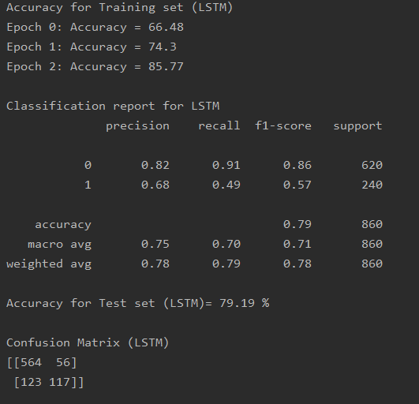

Accuracy for Training set (LSTM)

Epoch 0: Accuracy = 66.48

Epoch 1: Accuracy = 74.3

Epoch 2: Accuracy = 85.77

Classification report for LSTM

precision recall f1-score support

0 0.82 0.91 0.86 620

1 0.68 0.49 0.57 240

accuracy 0.79 860

macro avg 0.75 0.70 0.71 860

weighted avg 0.78 0.79 0.78 860

Accuracy for Test set (LSTM)= 79.19 %

Confusion Matrix (LSTM)

[[564 56]

[123 117]]